**Michael Echols, Chair**

Monroe

**Rex Alexander**

Lake Charles

**Marguerite Anderson**

West Monroe

**Waynette Ballengee**

Shreveport

**Pamela Breaux**

Lake Charles

**Dwayne Carruth**

Baton Rouge

**Missy Crews**

Baton Rouge

**Gena Gore**

Dry Prong

**Gerri Hobdy**

Baton Rouge

**Mary Lee**

Mandeville

**George Marks**

Arnaudville

**Barbara Motley**

New Orleans

**Patti Nelson**

Monroe

**Sheela Plater**

Thibodaux

**Michael D. Robinson**

Baton Rouge

**Jacques Rodrigue**

New Orleans

**Karen Dean Sharp**

Sterlington

**Kirk Talbot**

New Orleans

**Patrick Widhalm**

Natchitoches

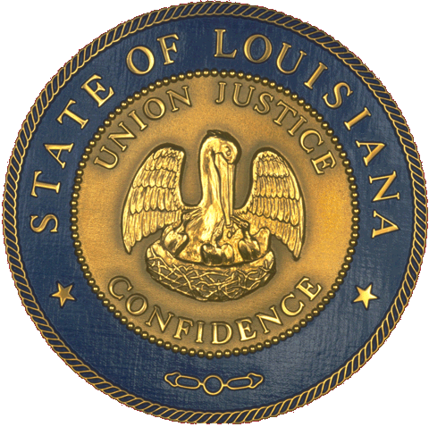

**State of Louisiana**

Office of the   
Lieutenant Governor

Department of Culture, Recreation, Tourism

Office of   
Cultural Development

**Louisiana State Arts Council**

**Quarterly Meeting Minutes**

**Capitol Park Welcome Center**

**Tuesday, April 14, 2015 at 2 p.m.**

**Council Members present:** Chairman Michael Echols, Rex Alexander, Jacques Rodrigue, Dwayne Carruth, Barbara Motley, George Marks, Gerri Hobdy, Karen Sharp, and Missy Crews.

**Council Members not present:** Pam Breaux, Patti Nelson, Waynette Ballengee, Marguerite Anderson, Gena Gore, Mary Lee, Kirk Talbot, Pat Widhalm, Michael Robinson, and Sheela Plater.

**Guests:** Gene Meneray and Connie Soto Learman

**LDOA Staff present:** Cathy Hernandez, Dana La Fonta, Paula White and Maida Owens

**I. Call to Order and Welcome**

The meeting was called to order at 2:05 p.m. by Chairman Echols.

**II. Approval of Minutes**

The approval of the minutes for the July 16, 2014 and August 25, 2014 meetings was tabled for the next LSAC meeting due to lack of a quorum. The notes from the February 24, 2015 meeting were also distributed.

**III. Chairman’s Reports**

Michael welcomed everyone to the 2015 Culture Connection, and he introduced the LSAC meeting’s two guests: Connie Souto Learman with the Mississippi Arts Commission (MAC) and Gene Meneray with the Louisiana Citizens for the Arts. Connie mentioned that she was at Culture Connection to honor Mississippi’s new relationship with Louisiana through the Gulf State Presenter’s Network (GSPN), and talked a bit about her work with MAC. She also explained that the GSPN initiative isi both a new grant program as well as a peer-to-peer network among presenters from the three states.

**IV. LDOA Director’s Report**

Cathy Hernandez reported that she has been working to raise dollars for the Gulf State Presenters Network (GSPN), and has learned that the project is one of 15 finalists in the nation for a $120,000 grant from the Duke Foundation. The project is also being considered by the Mellon Foundation for $150,000 over two years. Both grants could

serve as a required match for an NEA grant, since they have also shown interest in funding the project. The GSPN consists of forming a peer-to-peer network of presenters across the three states as well as a grant program where each of the three state arts councils offer presenters funding to book artists from the other two states. Cathy is also beginning work on the FY 16 – 18 Strategic Plan.

**V. LDOA Staff Reports**

1. **Grant-making:** Paula White reported that we have the Artist Career Advancement Grant and the Fast Track Gulf State Presenters Grant due in May.She also received over 70 applicants for the Stabilization Grant, and is currently double checking all of them for completeness. She asked that LSAC members that are interested in serving as a grant panelist to sign a sheet she’s circulating.
2. **Cultural Districts:** Cathy reported on behalf of Gaye that five LSAC members agreed to act as the review team this year: Sheela Plater, Waynette Ballangee, Rex Alexander, Gerri Hobdy, and Missy Crews. Three new Cultural Districts have been approved: Nellie Lutcher and the cities of Carencro and Patterson. There were also three boundary changes and one name change.
3. **Folklife:** Folklife got a nice increase in funding this year from the NEA. The program now has a $45,000 allocation. Things continue to go well with the Baton Rouge Project, which currently has a focus on music.
4. **Percent for Art:** Dana gave updates on several projects including the University Medical Center in New Orleans. That project has a $2.2 Million budget with artists such as Ray King and Chihuly installing art in the Spring of this year. She also mentioned that the LSU E Community Education Center in Eunice was going well. That project has a budget of roughly $66,000, and has selected artist Obie Simonis for the commission with a June installation.
5. **Arts in Education:** Jacques Rodrigue mentioned that LA A+ Schools is now serving seventeen schools with eight of them being new to the roster after being fully vetted by their approval process. The new schools are all over the state with two in Baton Rouge, one in Duson, and one in LaFayette as examples. Alfre Woodard will be working them during JazzFest as a Turnaround Artist with the President’s Committee on the Arts and Humanities.

**VI. LPA / LCA Report**

Gene Meneray reported that the LCA is in growth mode (working to grow the board and the budget), and is currently considering several projects including the development of an Arts Caucus and a new membership strategy. Barbara had earlier suggested that LSAC formalize its boundaries of working with the LCA.

**VII. New Business**

Gerri Hobdy suggested that research be done on creating an arts endowment of some sort to bring in additional arts funding to the state. Cathy will partner with her to look at the strategies / structures that various states have utilized.

**VIII. Public Comment**

There was no public comment.

**IX. Adjournment**

The meeting was adjourned at 3:00 p.m. upon motion of Dwayne Caruth, which was seconded by Rex Alexander, and unanimously passed by the Council.